James 3:1-12  James, the brother of Jesus, wrote a letter to Christians primarily concerned with UNITY in the Church. In chapter 3, he writes on the subject of “taming the tongue;” he’s worried about the church’s unity, and he realizes the tongue has the ability to divide a church perhaps more than anything else.  Our words have incredible power and weight. All of our lives have been shaped by the words spoken to us, spoken over us and spoken about us. Words are shaping our relationships, our view of ourselves and our view of God. Words can build up and give life, or they can be incredibly destructive.  We can destroy a person with our words without even being in the same room with them. Many of our greatest regrets relationally might have been avoided if we had embraced James’ teaching.  Words are not weighted equally. Negative words are heavier than positive words. We remember the hurtful words much better than the encouraging words. Some of you can probably remember hurtful words spoken to you from years ago. It takes many more positive words to counter the negative words. And, depending on who says the words, they can be heavier or lighter. Words from our family, friends our boss are heavier than other relationships.  In this chapter, James uses a variety of metaphors to illustrate just how powerful our words are.  He invites us to remember words’ potential for good and bad, and to surrender our tongues to God. |  |  | 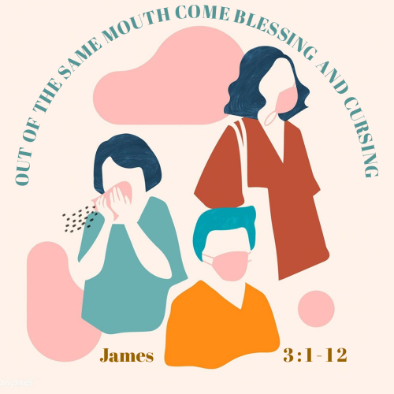  COMMON GROUND WOMENS’ RETREAT  - GENERATION CELEBRATION

 | Rudder on a Ship vv.3-5: Big Influence  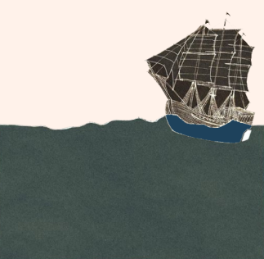 The tongue is a small part of the body but it has big influence. It can determine the direction and quality of our lives. How are your words influencing or steering others? How can our tongues steer us like a rudder steers a ship?  Dangerous Spark vv.5-6: Potentially Damaging  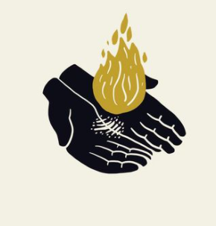 Sparks are much more likely to cause a forest fire in the Black Hills, than they are in a place like Florida. In the same way, the conditions of a culture or an individual’s life can make words more or less likely to cause damage. We must be aware of the conditions. When it comes to the words we speak, do we live in a dry or wet climate? What is the fire danger level in your relationships? How have you been “burnt” by the words of others in the past? In what ways can sparks be beneficial?  Venomous Animal vv.7-8: Needs a Cage  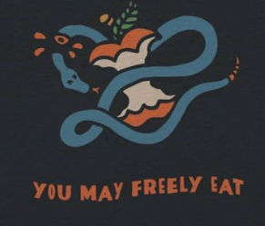 Tamed animals are predictable and safe. The tongue is unpredictable and dangerous. It cannot be allowed to roam free without supervision or boundaries. What “untamed” behaviors is your tongue prone to? What boundaries or training can we give our tongues? | Praise & Curse vv.9-10: Shouldn’t Be  We can praise Jesus one minute and curse the people who bear his image the next.  Has your speech included praise and cursing recently?  How have you justified cursing others in the past?  Flowing Spring vv.11-12: Life Giving  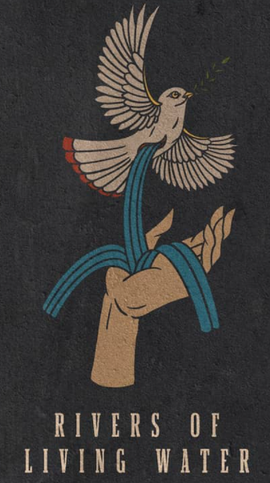 Springs are vital for life to flourish. A spring can give life to all who live near it. But, if it is salty, it can ruin an entire area making it impossible for anything to grow. How can words give life? Recall a time when someone’s words were a life-giving spring for you.  There were other illustrations James used such as a bridle for a horse, a fig tree and so on, that we did not discuss.  What other illustrations or statements from James chapter 3 stand out to you?

